Government Dau Kalyan Arts & Commerce Postgraduate College, Baloda Bazar, Chhattisgarh

Criterion 7- Institutional Values and Best Practices
Key Indictor- 7.1 Institutional Values and Social Responsibilities
Gender Equality
7.1.1 Measures initiated by the Institution for the promotion of gender equality during the five year.
Government Dau Kalyan Arts & Commence Postgraduate College Baloda Bazar is highly concern towards gender & sensitization in providing curricular and co-curricular activities for women in the college. To bring gender equality as per C.G. Government Higher Education Policy 30% of seats are reserved for female students.
- Safety and security
College operates under a completely secured campus. There is check at the entry point with guard. The campus has 12 CC TV cameras at the entrance gate, corridors and at all sensitive location of the institution.
Women Sexual Harassment Redressal Cell of the college is always active in the campus, under “The Sexual Harassment of Women at Workplace” (Prevention, Prohibition and Redressal). It meets on need basis to address any complaints from students, teaching and nonteaching members and takes necessary action. The college has a zero tolerance policy towards any such transgression. It is committed to provide a safe and conducive work and academic environment to the students and its employees and is extremely alert to the matters pertaining to any kind of harassment and gender sensitivity. There is nil complaint from 2016-21 in this regard.
https://gdkcbalodabazar.ac.in/Uploads/GDKCBalodaBazarCollegeComitee.pdf
Anti-Ragging Committee as per U.G.C. guideline Anti-Ragging Committee is formed to make sure that there are no instances of ragging anywhere on campus. Anti-Ragging posters are prominently displayed at all prominent places within the campus with help line numbers prominently displayed. Main gate is guarded and entry points are screened. Safety and security of all the students and staff is ensured.
https://gdkcbalodabazar.ac.in/Uploads/GDKCBalodaBazarCollegeComitee.pdf
- Counselling
The Counselling and Career Development Cell is constituted in the college. The goal if the cell is: To conduct psychometric testing, counselling, vocational guidance and life skill coaching. The cell all-round the year encourages the students to understand themselves, the issue that trouble them and guide them to resolve their problems. These problems can be personal, emotional, social, academic, sexual or related to their careers etc.
- Common Rooms
Common room facility is available for the female students with in campus. In girls common room sanitary pad vending machine is also installed.
- Any other relevant information
In the respect of women every year International Women’s Day is celebrated. For the safety of female students awareness programmes were organised by the college frequently.
Safety and Security CC TV Camera

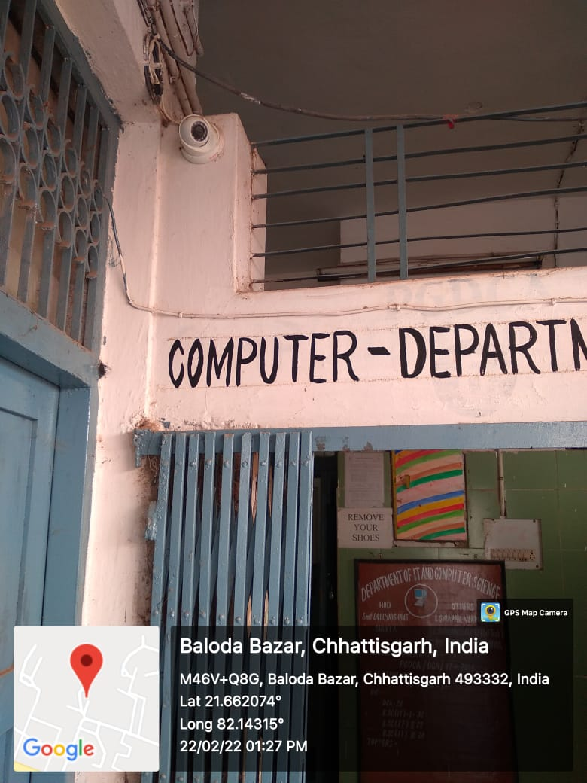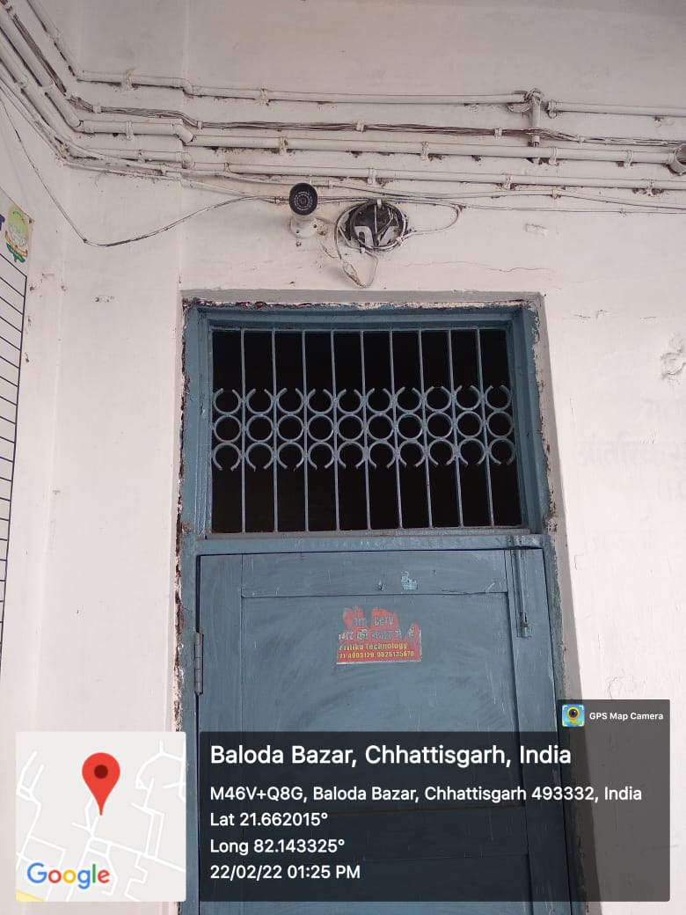
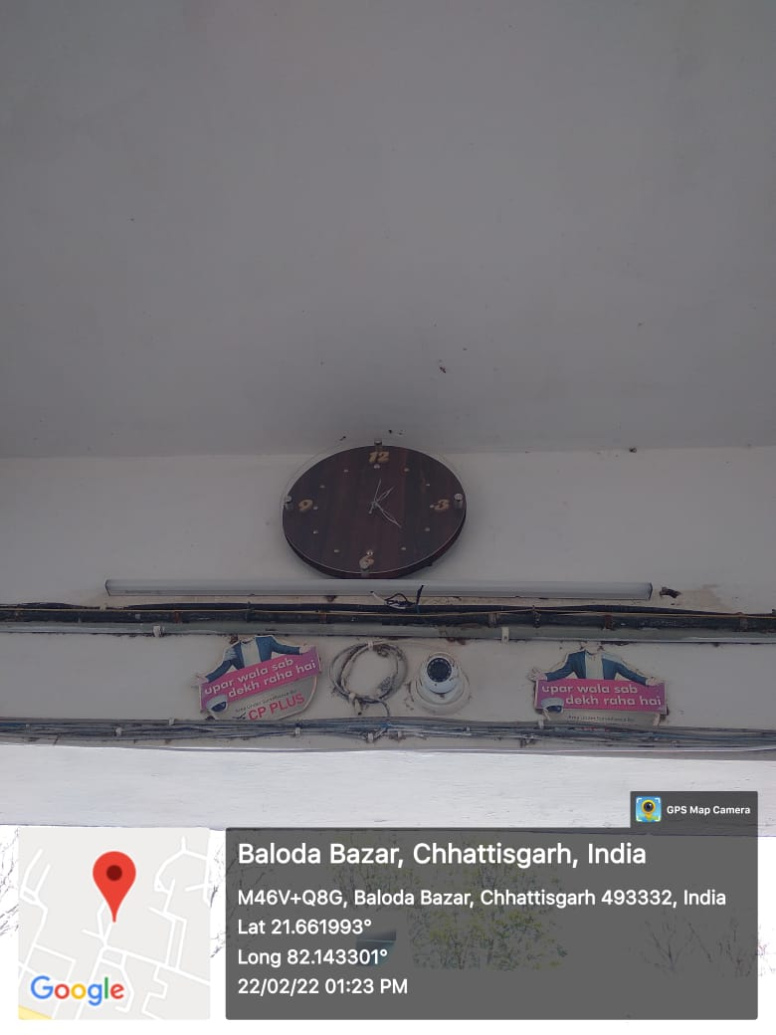

Women Harassment Redressal Cell

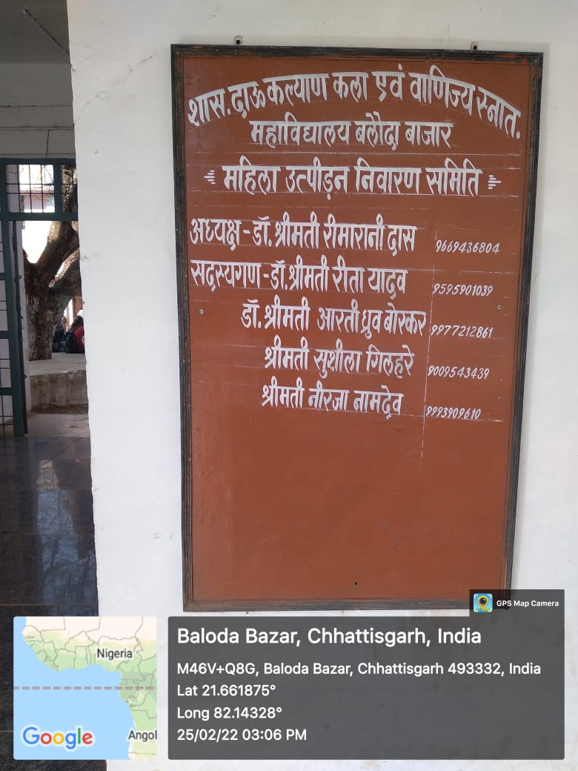

Report of Sexual Harassment Redressal Cell

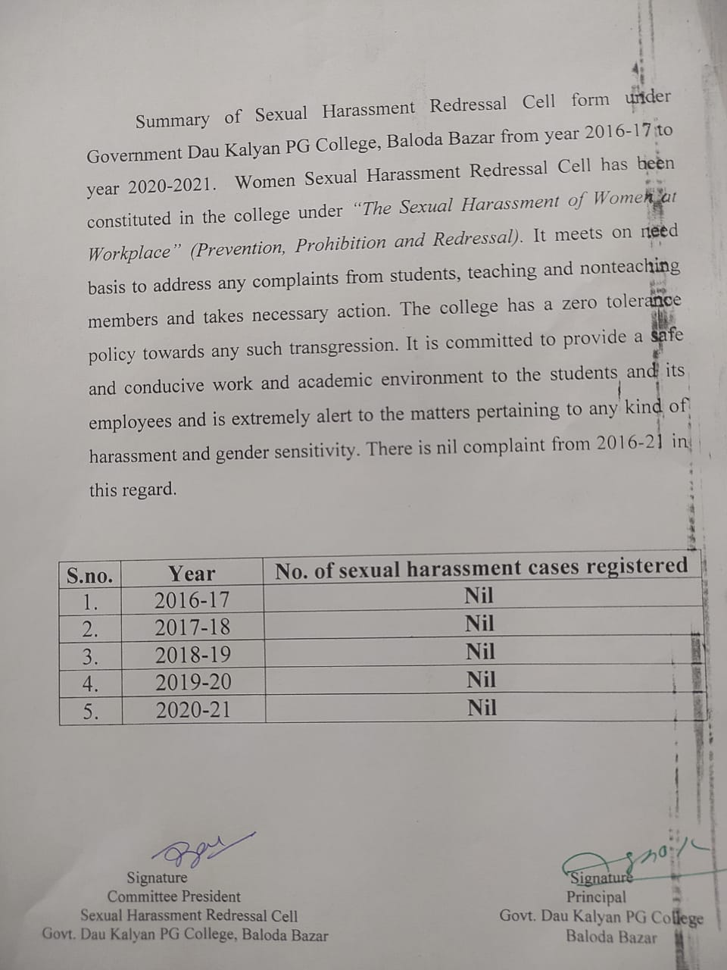

Anti-Ragging Committee

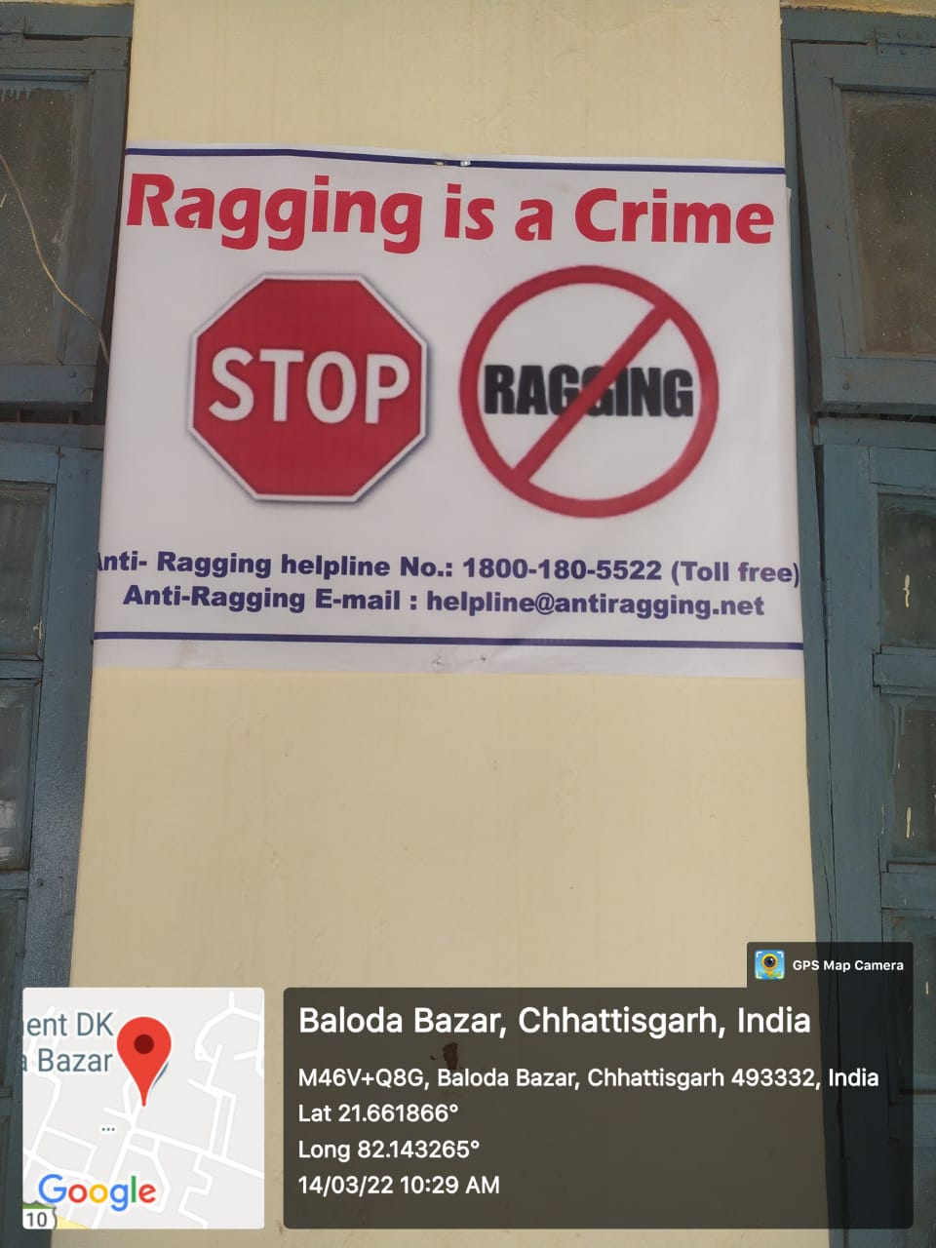

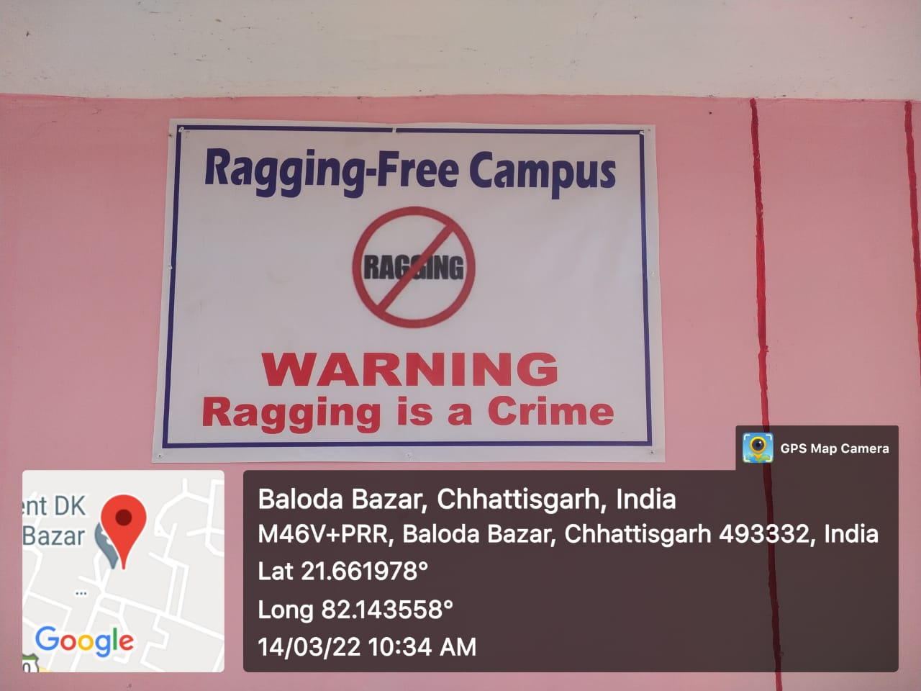

The Student Counselling, Career and Personality Development Cell

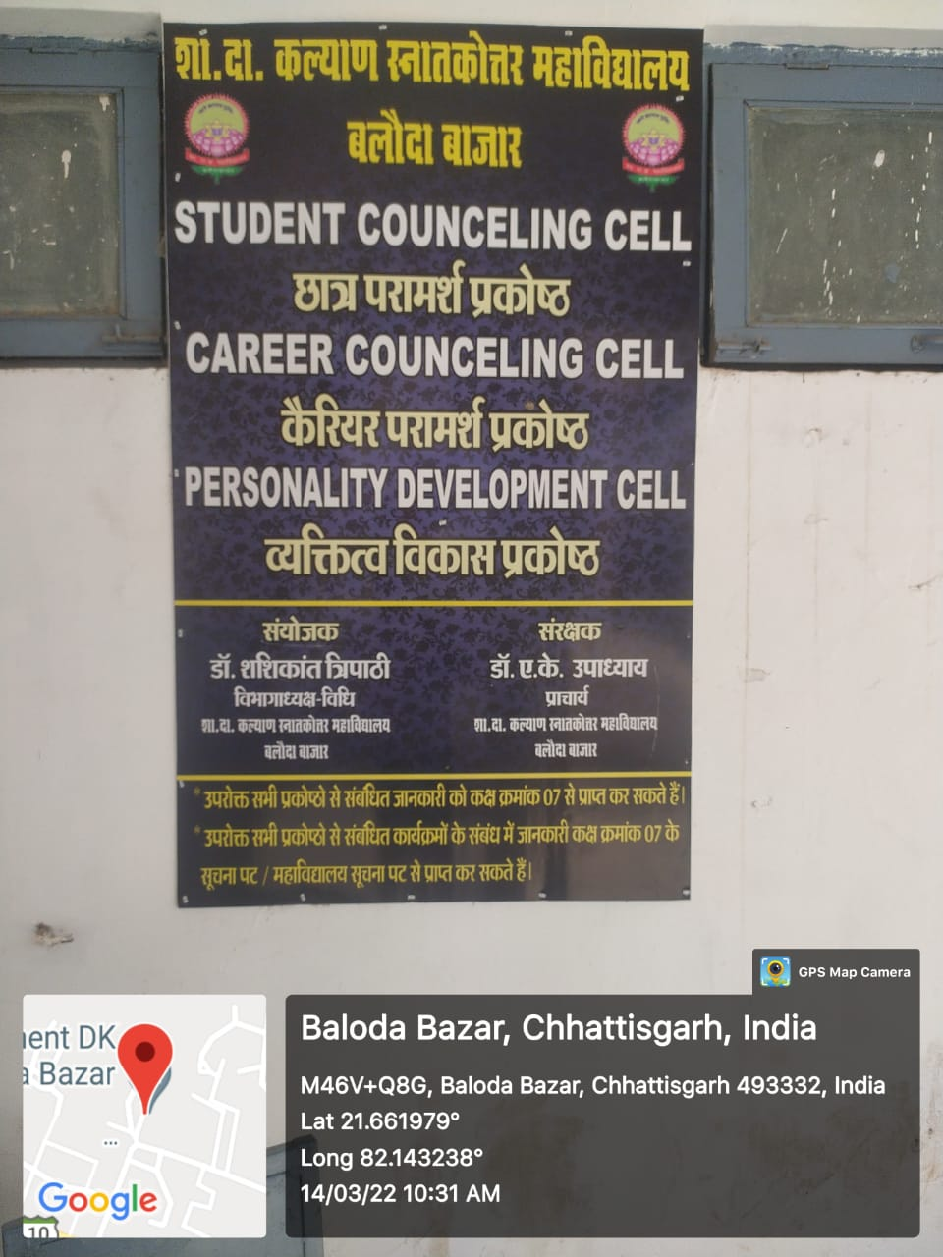

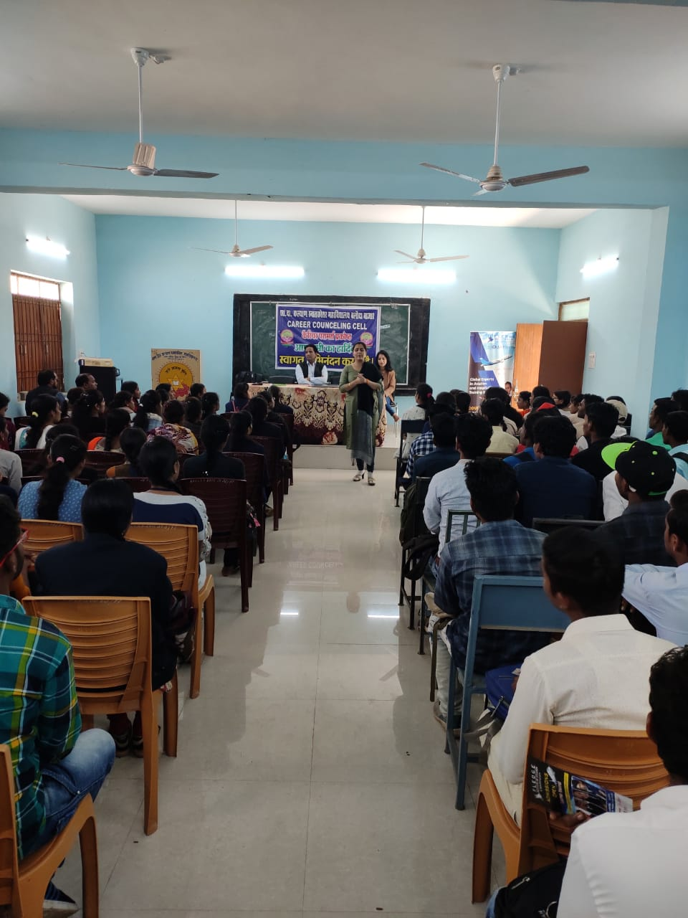

Common Room with Sanitary pad vending machine

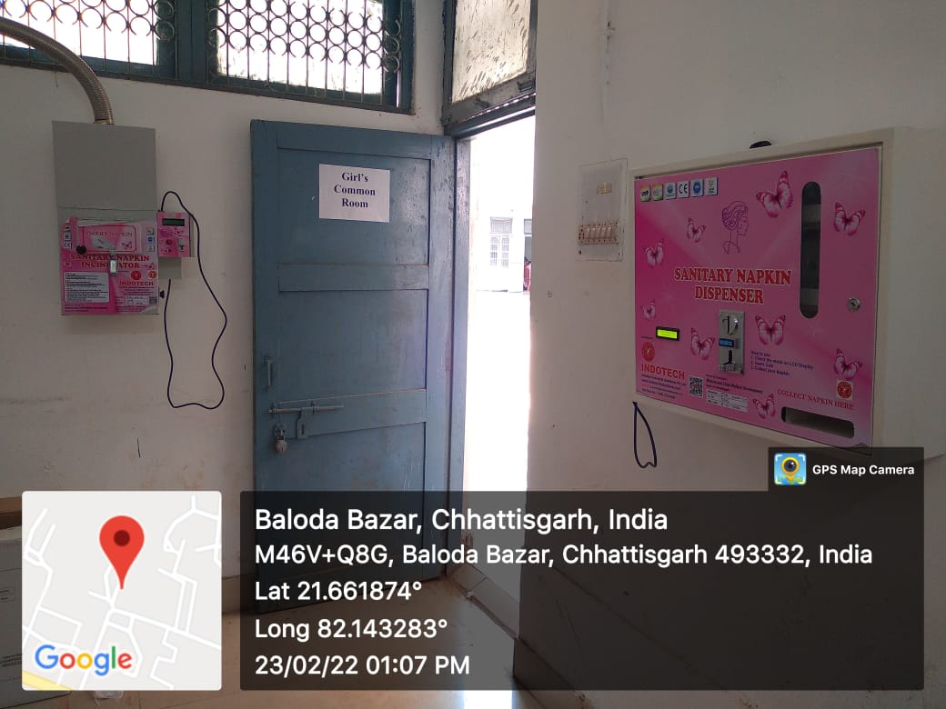
Other relevant information

Female students awareness programmes

